Murrayfield Medical Practice

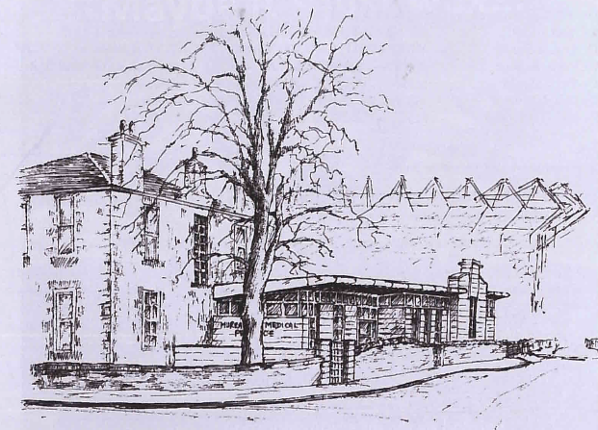

13b Riversdale Crescent
Edinburgh
EH12 5QX

0131 337 6151

www.murrayfieldmedicalpractice.scot.nhs.uk

Welcome to Murrayfield Medical Practice

This practice booklet has been prepared to help you get the best out of the services we offer. We trust you will find it informative and we suggest you keep it in safe place for future reference.

PRACTICE PERSONNEL

Doctors

Dr Angela Hamill
Dr Sarah Moran
Dr Denise Coleiro
Dr Eilidh Stimpson
Dr Caroline Bennett
Dr Joanna Stutchfield
Dr Dougal Binnie
Dr Neil Gallacher

Administration and Reception Staff

The Practice Manager Neil Porter ensures the smooth running of the practice on a day-to-day basis. If you have any comments or suggestions, please let him know.

Our Assistant Practice Manager, Mary Cox, will assist with any problems in the absence of the Practice Manager.

Our medical administrators will assist you in making routine and emergency appointments to see your doctor or nurse, undertake repeat prescriptions requests, arrange home visits and offer help and assistance at all times.

Please note: the reception staff will ask you for the reason for your appointment; this is to ensure it is made with the correct person and allocated the appropriate length of time.

The Nursing Team

The practice has two Practice Nurses, a Treatment Room Nurse and Phlebotomist. They work together to provide a comprehensive range of services. These include: -

Asthma Reviews | Blood Tests | Blood Pressure Checks
Cervical Smears | Diabetic Clinic | Wound Management
Dietary advice & weight loss support | Heart Disease Clinic | Family Planning Advice, including pill reviews
General Health/Lifestyle Advice | Immunisations | Hypertension Clinic
Well Woman Clinic | Travel Advice | New Patient Medicals
Smoking Cessation | Over 75 checks | Vaccinations

Our Practice Nurses are prescribers and can see patients for minor ailments and some drug reviews.

SURGERY TIMES

Doctor Surgeries

We offer a range of face to face and telephone appointments, both on the day, and pre-bookable up to 6 weeks in advance. The surgery telephone lines are open from 8am-6pm, Monday to Friday.

Doctor | Monday | Tuesday | Wednesday | Thursday | Friday
Dr Hamill | AM & PM | AM & PM | AM & PM
Dr Moran | AM & PM |  | AM & PM
Dr Coleiro |  | AM ONLY |  | AM & PM | AM & PM
Dr Stimpson |  | AM & PM |  | AM & PM | AM only
Dr Bennett |  |  |  | AM & PM | AM & PM
Dr Stutchfield | AM & PM | AM & PM
Dr Binnie |  |  | AM & PM | AM & PM | AM & PM
Dr Gallacher | AM & PM |  | AM & PM

The doctors cover on call in rotation and will not be available for routine appointments on these days.

The practice offers some early & late appointments, please ask the reception team for more information.

Some of our doctors have external commitments in other areas of the Health Service. On occasion these many affect their availability.

MEDICAL STUDENTS

The practice is a teaching practice and it may be that a student will be in attendance while you are having a consultation. Please let us know if you would prefer not to have the student present.
DISTRICT NURSES - Tel: 0131 313 5085

The District Nurses work in partnership with the GPs and other Health/Social Care professionals, carers and other agencies to provide an individualised holistic care for our patients in their own homes. They can offer nursing care and support to those who require palliative/cancer care, wound management, elderly assessment, vaccinations, injections and other clinical procedures.

HEALTH VISITOR - Tel: 0131 603 0240

Health Visitors are qualified nurses with specialist training in community health. They work in partnership with the local community, other health and social care professionals and voluntary agencies. They also promote and provide health information and support, provide home visiting and involvement in local groups/activities, offer assessment of health needs and information about local services. Examples of areas our health visitor can provide information, assessment and support are:

Being a parent Child protection issues
Family health worries Emotional Health
Healthy living Home safety
Pregnancy Your child’s health and development

MIDWIVES – Tel: 0131 286 5023

The midwives provide antenatal care before the baby is born and post natal support immediately after delivery. They are not based at the practice but can be contacted via the number above. The midwives consult at the practice on:

Wednesday | Antenatal & Booking Clinic

To book your first appointment with the midwife please phone 536 2009.

SERVICES AVAILABLE FROM THE PRACTICE

All GP practices are contracted to provide “Additional Services” i.e. basic treatment of ill people.

We provide a number of “Additional Services” which have been mentioned previously, e.g Smear Clinics, Child Health Surveillance etc.

The practice also holds contracts with Lothian Health Board to provide the following ‘enhanced services’:

- Regular monitoring by blood & urine tests, for patients with a range of drugs for arthritis.
- Annual comprehensive reviews for patients with heart disease, diabetes and asthma.
- Regular monitoring of Warfarin and lithium levels.
- Care for patients in nursing and residential homes.

SCREENING

Bowel Screening – this is an important test. The Scottish Bowel Screening Programmes will invite all men and women in Scotland between the ages of 50 to 74 for screening every two years. This programme is available in all NHS Boards. Bowel Cancer is the third most common cancer in Scotland. We would encourage all out patients to return the tests to the screening centre as early detection can save lives. If you are unsure you can always ask the GP’s or nurses for advice.

EMERGENCY APPOINTMENTS
Appointments with the duty doctor are by telephone in the first instance. They will call you and triage you appropriately arranging to provide treatment/advice, to bring you in face to face or to refer you to secondary care. You may have to wait to be seen if they are called out on an emergency. The doctor will endeavour to see patients as near to their appointment time as possible but please be aware that if the patient in front of you needs admitting to hospital you will be kept waiting

OUT-OF–HOUR EMERGENCIES
From 6pm to 8am Monday to Friday, all weekends and Public Holidays the out-of-hours care is provided by NHS24. If you require to be seen out-of hours (OOH) an appointment will be made for you at the most convenient OOH centre. Home visits will be provided where necessary. Transport to and from an OOH centre will be available for those who require face to face assessment, are clinically safe to travel and who cannot access suitable private or public transport.

In serious emergencies (such as a heart attack or stroke) dial 999 for an ambulance
To contact NHS 24 Telephone 111

HOME VISITS
Where possible, please phone before 10.30am to request a home visit. The receptionist may ask for details to determine the urgency of the request. Please only call for a visit if you are unable to make it to the practice, remember a doctor can see up to five patients in surgery in the time it takes to do a home visit.

TESTS AND TEST RESULTS
Any specimens needing to be tested should be handed into reception before 2:30pm. All results are seen by your doctor. Results can be given over the telephone after 10am to the person concerned, or you may attend the surgery – results can only be given out once your doctor has reviewed them, the administrators cannot tell you results without the doctors input. Please note we are unable to give any information to relatives or friends without written permission from the patient.

PRESCRIPTIONS
If you require regular medication, your doctor will put you on our repeat prescribing system which will enable you to obtain repeat prescriptions without seeing a doctor every time. Requests for repeat prescriptions should ideally be made on the Patient Services website. You can register for this service via our website or with your registration application. You can also post requests to the practice or place them in the ‘prescription slot’ at reception. You may collect your prescription from reception but if you wish us to send on your prescription please enclose a stamped addressed envelope. Some pharmacies operate a collection and delivery service; please notify the practice if you are involved in any of these schemes.

THE PRACTICE DOES NOT ACCEPT PRESCRIPTION REOUESTS OVER THE PHONE – THIS IS FOR THE SAFETY OF ALL PATIENTS

If you are on repeat prescription, you should see the doctor or nurse annually to have your medication reviewed.

NEW PATIENTS & HOW TO REGISTER
Anyone living in our area is eligible to register with the practice. Details of our practice area is available from reception or on our website. You will be asked to complete a registration form with which proof of address in the form of a utility bill, etc is required. We will also ask you to complete a health questionnaire. If you are on any regular medication you will also need to make an appointment with a GP to have your medication reviewed and put on our computer. There is no need to arrange a new patient check up unless you have on-going conditions.
On completion of the registration process you will be registered with the practice - not an individual GP - and you can then make an appointment to see any of our practitioners. We encourage patients to try and see one GP of their choice. If the GP of their choice is not available, you may be seen by any other clinician. Registrations can be made between 10am and 5pm.

PATIENTS RIGHTS & RESPONSIBILITIES
You will be treated with respect and as a partner in your care. Being a partner means you have responsibilities too. We will:

• Ensure our patients have 24 hour access to medical care.
• Aim for you to have access, by phone or appointment, to a suitable qualified medical professional within 48 hours of your initial contact during surgery hours, or in an urgent case, the same day.
• Work in partnership with you to achieve the best medical care possible.
• Involve you and listen to your opinions and views in all aspects of your medical care.
• The prevention of disease, illness and injury is a primary concern. The medical staff will advise and inform you of steps you can take to promote good health and a healthy lifestyle.

We would respectfully ask that you:
• Let us know if you intend to cancel an appointment or are running late.
•Treat staff with courtesy and respect. Administration staff may have to ask some personal questions to assist us in providing you with the best service.
• Inform the staff of any alterations in your circumstances, such as change of surname, address or telephone number. Please ensure we have your correct telephone number even if it is ex-directory.
• Use the emergency services provided by the practice responsibly.

The practice will not tolerate abusive or violent behaviour towards any member of the Practice Team. Unacceptable behaviour will result in the patient’s removal from our practice list.

CHANGE OF ADDRESS / TELEPHONE NUMBER
If you change your address please inform the reception staff as soon as possible. Remember to inform the hospital if you are waiting for an appointment or having treatment.
If you move outside the practice area you should register with a local doctor. The practice reserves the right to notify the healthboard you have moved out with the area and ask for your removal from the practice list. Please register locally before this happens.
If you change your home phone or mobile phone number please let the practice know as it is important if we have to contact you.

INTERPRETER SERVICE
The practice can arrange for an interpreter to be present during a consultation if the patient requests this. The appointment must be booked in advance and a double appointment will be required.

CHAPERONES
If you would like a chaperone present during a consultation with either the doctor or nurse please let them know and they will arrange this.

FACILITIES
The practice has a disabled parking space directly outside the main entrance. There is a ramp to the entrance. The doors are fitted with automatic openers for wheelchair users and pushchairs. Our waiting room, consulting room and toilet facilities are designed for wheelchair access.
There is a deaf loop system and for our younger patients the practice has children changing facilities and a toddler ‘toilet training’ seat and step.

PRIVATE / NON-NHS EXAMINATIONS
A number of examinations and reports for special purposes are not covered by the NHS. These are done privately at the discretion of the practice and a fee is payable.
These include: Private sick notes, insurance claim forms, holiday cancellation letters and some medical examinations.

CONFIDENTIALITY AND INFORMATION SHARING
The practice complies with Data Protection and Access to Medical Records legislation. Identifiable information about you will be shared with others in the following circumstances:

• To provide further medical treatment for you e.g. from district nurse and hospital services.
• To help you get other services e.g. from the social work department. This requires your consent.
• When we have a duty to others e.g. in child protection cases.

Anonymised patient information will also be used at local and national level to help our Health Board and Government plan services e.g. Diabetic care.

On occasion personnel within the Health Board need to check patient records to verify practice claims. If you do not wish your notes to be accessed by the Health Board Audit Team please inform the practice, in writing, so your records can be annotated. Details on the Freedom of Information Act can be found on a laminated patient information leaflet in the waiting room.

Data Protection: All patient information is held in accordance with the requirements of the Data Protection Act 1998. The practice is registered under the Data Protection Act, Registration No. Z7049630. Access to medical records is in accordance with the Data Protection Act 1998 and Access to Health Records Act 1990.

SUGGESTIONS AND COMPLAINTS
We welcome any constructive criticism or suggestions that would improve the service we provide for you. We operate an in-house complaints procedure and would ask in the first instance that you complete a complaints form or make an appointment to speak to the Practice Manager. The complaint will be investigated promptly and thoroughly and you will be notified of the conclusion and of any action taken. If you are not satisfied with this outcome you will be directed as to where you can obtain further help.

PARKING
Parking is restricted around the immediate practice area. Disabled parking is available in front of the entrance. There is a cycle bay through the staff car park.

BUSES
From Princes Street:- 12/31/26 From Corstorphine:- 12/31/26

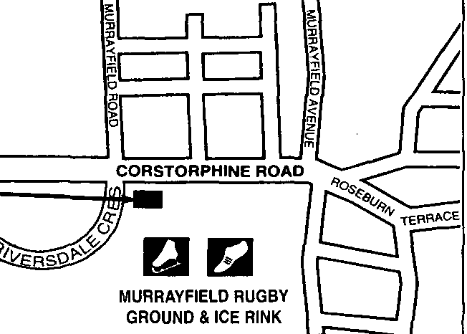
How to find us



Self Treatment

Colds, Sore Throats and Flu
Most of these are caused by a virus for which there is no treatment. You can help the body fight the infection by taking Aspirin or Paracetamol regularly (as directed on the packaging), plenty of fluids to drink and resting. Paracetamol can relieve a sore throat. Children can safely be given Paracetamol liquid (Calpol), but do ask the doctor if you are worried.
If you are coughing up a dirty spit or have pus on your tonsils you may need to see the doctor for an antibiotic.

Diarrhoea and Vomiting
Again, this is usually caused by a virus. Take fluids only for 24 hours. Contact the surgery if you cannot keep down fluids (this is very important with babies and young children). Adults can take medicine to slow down diarrhoea (see your pharmacist for suitable medicine).

High Temperature
The 3 important things to do when an adult or child has a high temperature are:
• Drink plenty, as you will sweat a lot.
• Take Paracetamol every 6 hours. This also helps the aches and headaches.
• Sponge the body with cool water, don’t dry it off. The body heat will dry it, bringing down the temperature.
If the person is very unwell or not beginning to get better in 2 or 3 days, then phone the doctor for advice.

Remember that your local pharmacist can give you good advice about medicines.

THE NHS PHARMACY FIRST SERVICE
AT YOUR
COMMUNITY PHARMACIST

Everyone can go to their nearest pharmacist for advice or to buy a medicine for a minor illness of complaint. It means that, if your pharmacist thinks you need it, they can give you medicine for a minor illness or complaint without you paying for it. It will save you making an appointment with your GP simply to get a prescription for a minor complaint.

Back ache, sprains and strains | Haemorrhoids | Minor fungal infections of the skin
Constipation | Headache and fever | Sore throat
Coughs | Heartburn and indigestion | Teething
Diarrhoea | Insect bites and stings | Threadworm
Earache | Mild eczema and dermatitis | Thrush
USEFUL TELEPHONE NUMBERS

Practice
Murrayfield Medical Practice________________________________ 0131 337 6151
District Nurse_____________________________________________ 0131 313 5085
Health Visitor_____________________________________________ 0131 603 0240
Midwives________________________________________________ 0131 286 5023
NHS 24____________________________________________________________ 111
(for advice during normal working hours and after hours service)

Hospitals

Royal Infirmary of Edinburgh_________________________________ 0131 536 1000
Western General Hospital___________________________________ 0131 537 1000
Royal Hospital for Sick Children______________________________ 0131 536 0000
Royal Edinburgh___________________________________________ 0131 536 6000
St. Johns Hospital, Howden___________________________________ 01506 523 000

Counselling and Help lines

AGE Scotland______________________________________________ 0800 124 4222
Alcoholics Anonymous_______________________________________0800 917 7650
Child Line (24 hours)___________________________________________ 0800 1111
Citizens Advice Bureau______________________________________ 0131 510 5510
CRUSE (Bereavement Counselling _____________________________ 0808 808 1677
Samaritans____________________________________________________ 116 123
Child Protection - Children 1st ________________________________ 08000 28 22 33
Vocal Carers Advice_________________________________________ 0808 196 6666
NOTES

…………………………………………………………………………………………..

…………………………………………………………………………………………..

…………………………………………………………………………………………..

…………………………………………………………………………………………..

…………………………………………………………………………………………..

…………………………………………………………………………………………..

…………………………………………………………………………………………..

…………………………………………………………………………………………..

…………………………………………………………………………………………..

…………………………………………………………………………………………..

…………………………………………………………………………………………..

…………………………………………………………………………………………..

…………………………………………………………………………………………..

…………………………………………………………………………………………..

…………………………………………………………………………………………..

…………………………………………………………………………………………..

…………………………………………………………………………………………..

…………………………………………………………………………………………..

…………………………………………………………………………………………..

…………………………………………………………………………………………..

…………………………………………………………………………………………..

…………………………………………………………………………………………..

…………………………………………………………………………………………..

