 | 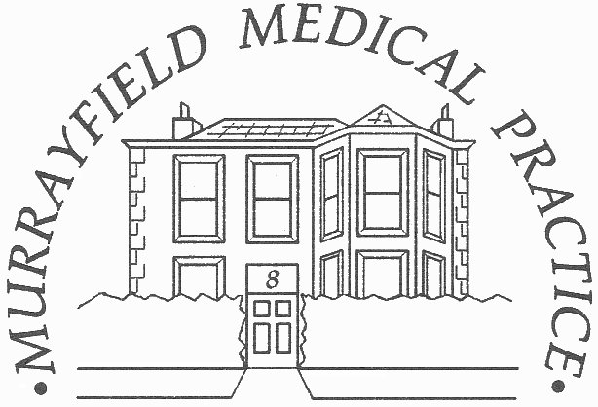
 |  | 13b Riversdale Crescent
Dr. Angela M. Hamill |  | Murrayfield
Dr. Dougal Binnie |  | Edinburgh
Dr. Sarah Moran |  | EH12 5QX
Dr. Denise Coleiro  Dr. Eilidh Stimpson  Dr. Caroline Bennett  Dr. Jo Stutchfield |  | Tel: 0131 337 6151
ETHNICITY & LANGUAGE QUESTIONNAIRE

This short questionnaire will give us some basic information about your communication support needs and ethnicity to help us support your health care. We would be grateful if you could complete one form for each family member.

NAME .......................................................................................... DOB .................................................

What is your main language:
Do you need an interpreter?
(if yes, which language)
Do you need sign language support?

WHAT IS YOUR ETHNIC GROUP?
Choose ONE section from A to E then tick the box which best describes your ethnic group or background.

A. White |  |  |  |  | D. African
Scottish |  |  |  |  | African, African Scottish, African British
English
Welsh |  |  |  |  | E. Caribbean or Black
British |  |  |  |  | Caribbean, Caribbean Scottish or
Irish |  |  |  |  | Caribbean British
Polish |  |  |  |  | Black, Black Scottish or Black British
B. Mixed or multiple ethnic groups
Any mixed or multiple ethnic group
 |  |  |  |  | F. Other (please specify)
C. Asian, Asia Scottish or Asian British
Pakistani, Pakistani Scottish or Pakistani British
Bangladeshi, Bangladeshi Scottish or Bangladeshi British
Chinese, Chinese Scottish or Chinese British
Indian, Indian Scottish or Indian British

If you would prefer not to provide this information, please tick here:
If you do not know your ethnicity, please tick here:

